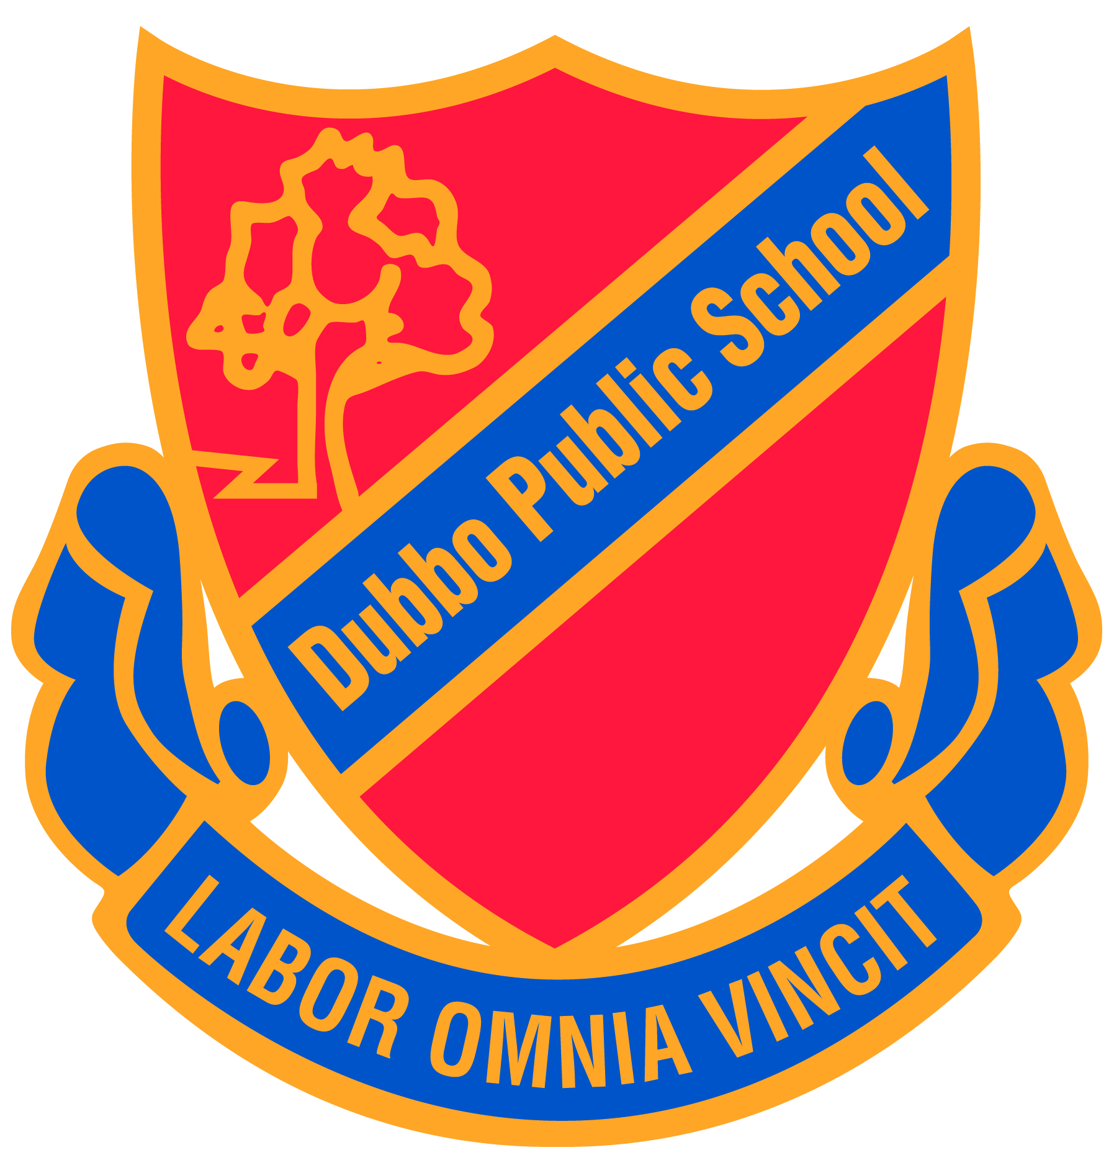
Dubbo Public School
181 Darling Street
DUBBO NSW 2830
Phone 6882 2399
Email: dubbo-p.school@det.nsw.edu.au

Dear Parents
Three Way Conference Bookings – Instructions

Three way conferences will be held in Week 4 (13 August to 17 August). If you have any queries or concerns or require assistance with your booking, particularly those parents who do not have email or internet access, please telephone the school on 6882 2399. Simply navigate to the site below and follow the steps to complete your booking online:

Go to www.schoolinterviews.com.au
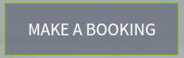 enter the code p6vz4
Enter your details
Select the teachers you wish to see

Select the appointment times that suit your family best

When you click FINISH your selected bookings will be emailed to you immediately.
If you not receive your email, please check your junk-mail, or enter the event code again and check your email address spelling. Update your details if email address is incorrect.

DO NOT DELETE the email you receive. Keep it somewhere safe. You may need to refer back to it later.

REMEMBER TO ADD YOUR APPOINTMENTS TO YOUR CALENDAR - reminders will not be sent home.

Bookings must be finalised by 10 August at 1.00pm

If you need to view, cancel, change or print your bookings:

- Click on the link in the confirmation email you received after you made your bookings
- OR return to www.schoolinterviews.com.au and enter the code and the email address you used when making your bookings.

Regards

Debbie Pritchard
Principal

